Data Flow Diagram
Date | 10/07/2026
Name | SYED MOHAMMAD KHAJA
Project Name | Credit Card Approval Prediction
Maximum Marks | 2 Marks

Data Flow Diagram:
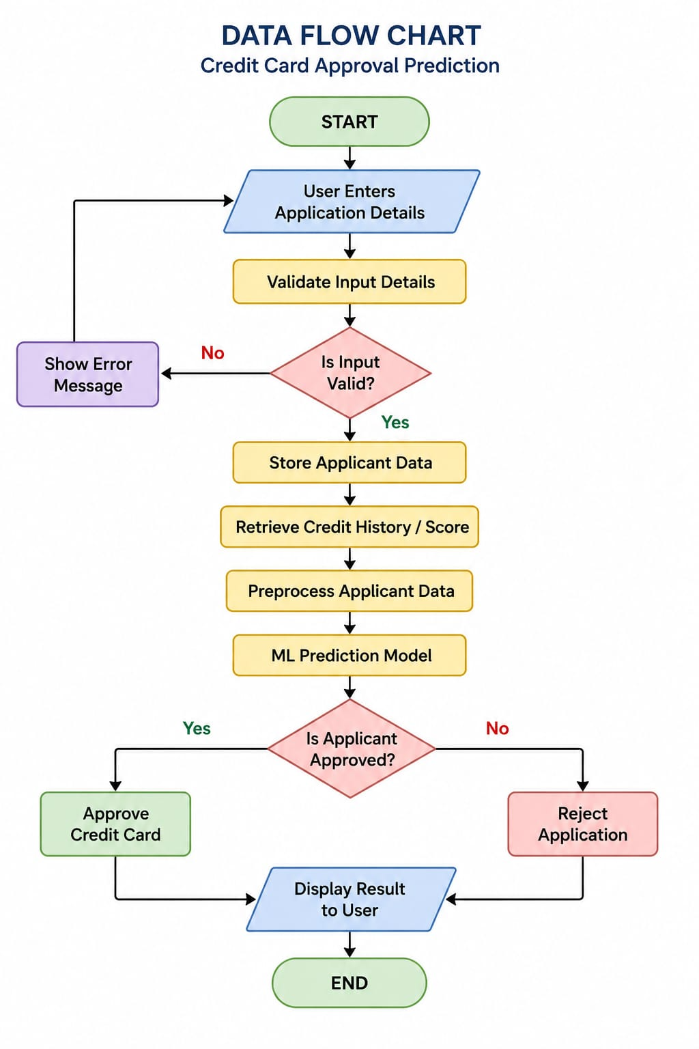

Flow Steps
- Start
- User Enters Application Details
- Validate Input Details
- Decision: Is Input Valid?
  - No → Show Error Message → Return to Application Form
  - Yes → Continue
- Store Applicant Data
- Retrieve Credit History / Credit Score
- Preprocess Applicant Data
- ML Prediction Model
- Decision: Is Applicant Approved?
  - Yes → Approve Credit Card
  - No → Reject Application
- Display Result to User
- End

